

TRIBHUVAN UNIVERSITY

INSTITUTE OF SCIENCE AND TECHNOLOGY



HIMALAYA COLLEGE OF ENGINEERING

CHYASAL, LALITPUR

LAB REPORT NO. 12

**SUBMITTED BY: SUBMITTED TO:**

NAME: ABIN TIMILSINA DEPARTMENT OF Bsc. CSIT

ROLL NO.: 04 CHECKED BY:

**Theory:**

*Pointer:*

It is a variable which holds the address of another variable.

***Syntax:***

<data_type>*<variable_name>

**& operator:**

* It is unary operator and also called address or referencing operator.
* Operand must be variable name.
* It gives address of operand.

**\*operator:**

* It is also unary operator and also called dereferencing operator.
* It takes address as an argument or operand.
* It returns value or content whose address is its argument.

**Dynamic Memory Allocation (DMA)**

DMA is a technique that enables programmer to allocate memory at runtime (execution time).

**Header file for DMA function:**

<stdlib.h> OR <alloc.h>

There are four types function related to DMA they are:

1. Malloc()
2. Calloc()
3. Realloc()
4. Free()

**Question 1**

**Write a c program to find the biggest among three number using pointer**

*Program:*

#include<stdio.h>

int main()

{

int a,b,c,*x,*y,*z;

printf("Enter 1st number \n");

scanf("%d",&a);

printf("Enter 2nd number \n");

scanf("%d",&b);

printf("Enter 3rd number \n");

scanf("%d",&c);

x=&a;

y=&b;

z=&c;

if(*x>*y && *x>*z)

{

printf("the greatest number is %d",*x);

}

else if (*y>*x && *y>*z)

{

printf("The greatest number is %d",*y);

}

else

printf("The greatest number is %d",*z);

return 0;

}

*Output:*

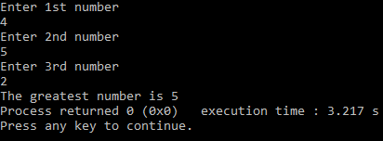

**Question 2**

**Write a c program to search an element on array using pointer.**

*Program:*

#include<stdio.h>

int main()

{

int a[5]={1,2,3,4,5},*p,n,i,flag=0;

p=a;

printf("enter a number for search \n");

scanf("%d",&n);

for(i=0;i<5;i++)

{

if(*(p+i)==n)

{

printf("element found on index= %d",i);

flag=1;

break;

}

}

if(flag==0)

{

printf("element not found");

}

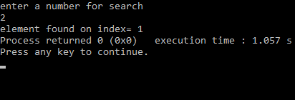 return 0;

}

*Output:*

**Question 3**

**Write a c program to read an array of size 8 and change its element by adding 3 using pointer and return type function**

*Program:*

#include<stdio.h>

int* change(int*);

int main()

{

int a[8];

int*p,i;

p=a;

printf("enter value of array element \n");

for(i=0;i<8;i++)

{

scanf("%d",(a+i));

}

p=change(a);

printf("change array element are \n");

for(i=0;i<8;i++)

printf("%d\t",*(a+i));

return 0;

}

int* change(int *ptr)

{

int i;

for(i=0;i<8;i++)

{

*(ptr+i)=*(ptr+i)+3;

}

return ptr;

}

*Output:*

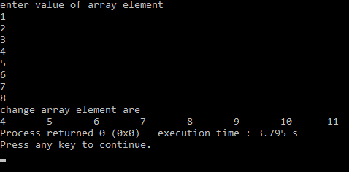

**Question 4**

**Write a c program to copy one string to another string using pointer.**

*Program:*

#include<stdio.h>

int main()

{

int l,i;

char str[10],str1[10];

char *p;

p=str;

printf("enter any string \n");

scanf("%s",p);

for(l=0;*(p+l)!='\0';l++)

for(i=0;i<=l;i++)

{

str1[i]=*(p+i);

}

str1[i]='\0';

printf("the copied string =%s",str1);

return 0;

}

*Output:*

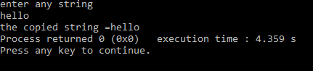

**Question 5**

**Write a c program to create structure named Book having bid, title and price as member from used and display their value using pointer.**

*Program:*

#include<stdio.h>

struct book

{

int bid;

char title[20];

float price;

};

int main()

{

struct book b;

struct book *p;

p=&b;

printf("enter id of book \n");

scanf("%d",&p->bid);

printf("enter title of book \n");

scanf("%s",p->title);

printf("enter price of book \n");

scanf("%f",&p->price);

printf("\tId of book =%d\n Title of book=%s\n Price of book=Rs %f\n ",(p->bid),(p->title),(p->price));

return 0;

}

*Output:*

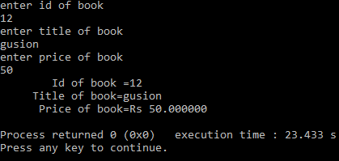

**Question 6**

**Write a c program to find sum of array element of size n using DMA**

*Program:*

#include<stdio.h>

#include<stdlib.h>

int main()

{

int n,i,*p,s=0;

printf("enter the size of array \n");

scanf("%d",&n);

p=(int*)malloc(n*sizeof(int));

if(p==NULL)

{

printf("memory not allowed");

exit(0);

}

printf("enter the value of element in array \n");

for(i=0;i<n;i++)

{

scanf("%d",p+i);

s=s+*(p+i);

}

printf("sum of array element =%d",s);

free(p); return 0;

}

*Output:*

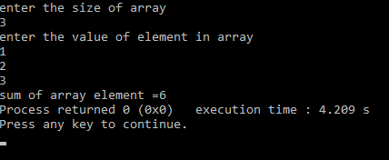

**Conclusion:**

From this we can conclude or we learnt about **Pointer** and how it is used in array, function, string , structure which makes us easy for programming and we also learned about various types of **Dynamic Memort Allocation (DMA) function.**